### Current Activities

The week of events in September to mark the 60th anniversary of IBM at Hursley began with the Heritage Open Day on Sunday 16th. Something over 200 people had registered to attend, but it felt like a lot more circulating around the museum.

The following weekend included an Open Day for employees, families, retirees and probably anyone else who turned up. This was a huge success, the museum was absolutely heaving the whole time, with every room absolutely packed with people. The curators had a busy time answering questions, so much so that we don’t have any photographs to show for it. We do however have a lot of [good positive feedback in the visitors’ book](http://slx-online.biz/hursley/fdbk.asp).

As part of the 60th Anniversary celebrations the lab also held a Festival of Innovation earlier in the week. This was in two parts. One featured many business partners and guests showcasing the latest technology but which gave many the chance to visit the museum and see what has already been achieved. This was opened by Kate Russell from the BBC's Technology programme "Click" who later tweeted:

*"Anyone who loves computers and history HAS to go visit the museum at* [*~~@~~****hursley_park***](https://twitter.com/hursley_park) *.. thank you so much for the tour xx "*

Schools in the region were also invited, and participated in a problem-solving project involving several areas of the museum. The day was a resounding success for the pupils and their teachers. It generated a huge amount of interest for future school outings, to further explore the museum and in particular its operational artefacts, an area in which we are placing ever greater focus.

### Discoveries

Those of you who have visited Hursley and been around the museum back office may remember the large walk-in safe. This would have been positioned against the wall of the earlier House before the 1903 extensions were built. A second safe of the same size sits on top of it, with access from a conference room on the floor above. Above that, in the same room, is a further smaller safe, and as long as I’ve been volunteering at Hursley we’ve wanted to see what is in there. Not only did we not know where to find the key, the safe itself sits high up and is difficult to reach.

A while ago scaffolding appeared in the room for some maintenance work, and my colleague Nick managed to locate a key. At last the great reveal – over 300 cardboard boxes, all numbered, containing ALD printouts (Automated Logic Diagrams), other print runs and punch cards. With no obvious explanation of what the contents were related to, or why they are there, we removed a small number for further examination.

A few attempts at working out what the project was were fruitless. Last week, I opened another of the boxes to find a printout which included in the heading reference to MT 2040. Machine Type 2040 was the S/360 model 40 CPU. We therefore believe we have found the complete S/360-40 logic diagrams, but still no idea why they were secreted there.

### Computer Museum NAM-IP

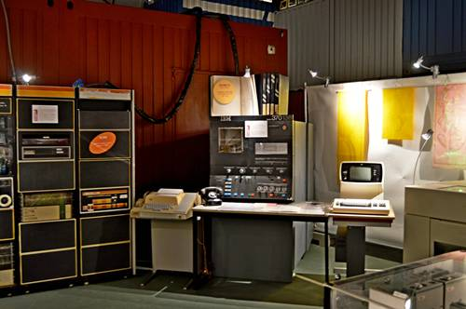Earlier this year, Gilbert Natan contacted us from the [**Computer Museum NAM-IP**](http://www.nam-ip.be/)in Namur, Belgium, looking for help for an exhibition planned this November. We were able to provide a large number of scanned photos and some technical information. The exhibition has now opened, and looks very interesting. The S/370 is a model 138, developed in Hursley.

Have a look at their [web site](http://www.nam-ip.be/) for more information.

### Donations

We continue to receive donations of hardware, documentation and other artefacts. The latest arrivals include a PC-AT and some older non-IBM kit including Commodore and Acorn micros, for which we have found new homes with enthusiasts in Hursley. On the CE front we have coming some ESCON tools, including laser light source and light meter for measuring propagation / attenuation in fibre cables.

During the Open Day, a former colleague from my early days in Hursley offered us a 4691 ‘Moonshine’ leisure / pub terminal. This was based on the PC-XT, with waterproof membrane keyboard. It needs a good clean after 30 years in his garage, and he has promised to do that before we receive it. My first job when I moved to Hursley from Greenock was competitive analysis for this machine!